**The Asteroid Prophecy by Efrain Rodriguez**

**: The Biblical Understanding of the Beginning of Sorrows**

**True Vine, Seoul, Korea / August 30, 2015**

**http://blog.daum.net/gracemjun/598**

<\*My personal understanding is written in red with (True Vine). Please note that I am not a Bible expert nor a prophet, just a watchman. But the Lord has helped me to gain a better understanding of the asteroid prophecy by Efrain Rodriguez in conjunction with the following scriptures including Habakkuk 3. Please pray to the Lord for discernment. May the Lord bless His church and His people!>

**1. The Beginning of Sorrows**

**(Luke 21)**

11 And great earthquakes shall be in divers places, and famines, and pestilences; and **fearful sights** and great signs shall there be from heaven.

25 And there shall be signs in the sun, and in the moon, and in the stars; and upon the earth distress of nations, with perplexity; the sea and the waves roaring;

**♤ Meaning:**

**(True Vine)**

**upon the earth...nations:** the entire world, not any single nation

**the sea and the waves roaring:** tsunami and tidal waves

**distress... with perplexity:** the beginning of sorrows (=the hour of temptation in Revelation 3:10)

**Signs in the sun:**

Total Solar Eclipse - March 20, 2015 (Dedication of Moses' Tabernacle)

Partial Solar Eclipse - September 13, 2015 (Feast of Trumpets)

**Signs in the moon:**

Blood Moon - April 15, 2014 (Passover)

Blood Moon - October 8, 2014 (Feast of Tabernacles)

Blood Moon - April 4, 2015 (Passover)

Blood Moon - September 28, 2015 (Feast of Tabernacles)

**Signs in the stars:**

'Star' means 'aster' in Greek. Stars refer to asteroids. (fearful sights = asteroid impact events)

**gold_star-850[1] Signs in the Stars by Pastor Perry Stone**

**(youtube: https://www.youtube.com/watch?v=lGEhX3I83M0)**

"...He (Josephus, a Jewish historian) also said this. Let's show the next picture. He said a star shaped like a sword appeared in the heavens. This, I'm showing you right now, was taken in Italy 4 years before 9/11. That is a meteorite shower taking place in the pole Leo the Lion. They call it Leo the Lion. The emblem of Judah is the lion. Coming out of this pole was this meteorite shower that looked like a sword. It's shaped like a sword in the heavens. You can see. There are some pictures when you take a closer look, you can even see how it comes to a point. I believe in the destruction of the Temple that is what they saw hanging over the city for a period of time prior to the destruction."

[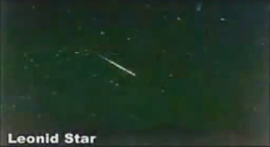](javascript:close();)

**\*A meteorite shower taking place in the pole Leo the Lion, captured in Italy 4 years before 9/11**

**C:\Users\전민정\AppData\Local\Microsoft\Windows\Temporary Internet Files\Content.IE5\8U32Q0XH\gold_star-850[1].jpg The Asteroid Prophecy by Prophet Efrain Rodriguez**

**(youtube:** [**https://www.youtube.com/watch?v=6gfXdDLzzrA**](https://www.youtube.com/watch?v=6gfXdDLzzrA)**)**

**(True Vine)** A meteorite shower appeared over Puerto Rico around 2 a.m. on December 28, 2014, captured at different angles by the cameras of the Astronomical Society on the island of Puerto Rico. The meteorite shower looks like a sword or an arrow and comes out of right next to the Lion's face formed with clouds in the video. "The emblem of Judah is the lion." Please note that, according to Pastor Perry Stone as in the above, the sword-shaped meteorite shower coming out of 'Leo the Lion' appeared in the sky of Jerusalem prior to the destruction of the Temple in AD 70. So this meteorite shower over Puerto Rico did not come by accident, either. But it came as a sign of the coming destruction to the United States and the nations. The fact that it was captured at different angles by the cameras signifies that the judgment will come to pass in all directions affecting the entire world. The important thing to notice is that the meteorite shower came around 2 a.m. on December 28, 2014, just 18 months later after the passing of Evangelist Yiye Avila who died on June 28, 2013. Prophet Efrain prophesied that Yiye Avila's death was given as a sign for the asteroid judgment.

As a personal testimony, the Holy Spirit spoke to me on December 17, 2014, "Be prepared to receive angel's cloud." At first, I did not know what the angel's cloud meant, whether literal or metaphorical, but I came to realize on January 4, 2015 that the angel's cloud was the Lion's face on the clouds in the video.

**(Prophet Efrain) ...** I was praying, asking God to give His servant Yiye Avila, the great Puerto Rican Evangelist, more time here on earth, because I knew that Yiye's parting with the Lord, whenever it happened, was to be the sign that God had chosen for Puerto Rico as prelude to this judgment, in order for His true church (small) to be able to prepare itself, and would be able to escape to the mountains, just like Lot did when The Lord's angels told him where to go. Scripture says that The Lord will not do anything until He first reveals His secrets to His servants, the prophets. Thusly, God, who is in Heaven, is being faithful to His servants here in Puerto Rico, and to all the righteous in the island. For this reason, He told me: "My servant... soon I will take my servant Yiye Avila and I will allow for my people to honor him." He said: "As soon as Yiye is laid to rest, immediately I will send my judgment to the island." (It is in God's time... not ours) Note: Yiye Avila has now gone to be with The Lord, as of June 28, 2013. This message was received and written before Yiye's passing.

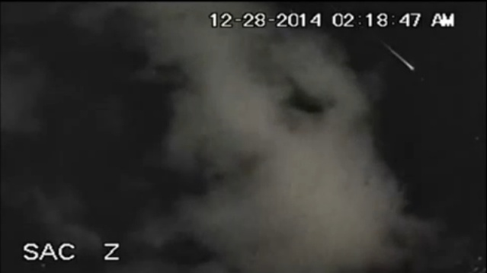 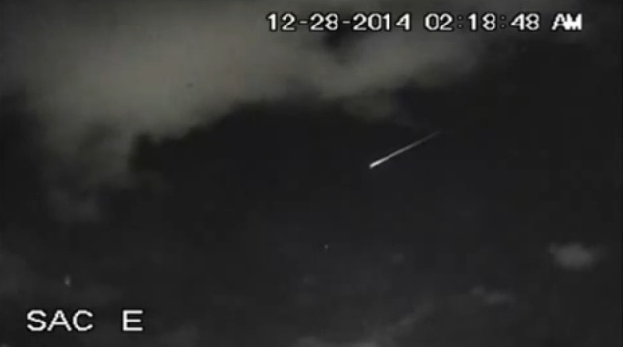

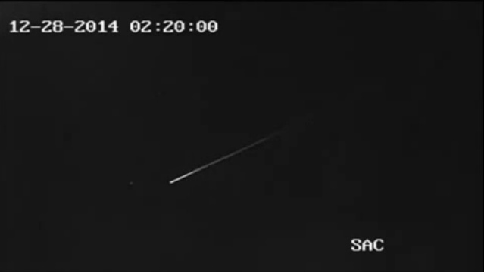 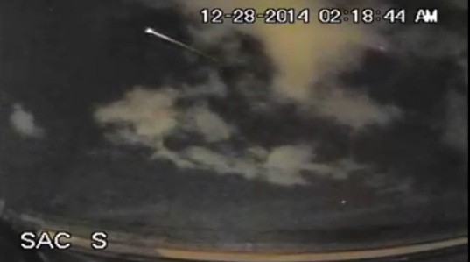

**\*The Meteorite Shower over Puerto Rico on December 28, 2014**

So what happened then? As a matter of fact, the judgment came on December 28, 2014 in the sky, in the heavenly spiritual realm. "Thy will be done in earth, as it is in heaven. (Matthew 6:10)" Therefore, it will come to pass on earth very soon as well. A lady named Sandy Bergmann received a message from the Lord on January 12, 2015 about why the asteroid judgment was delayed a little while in the natural realm.

**(Sandy Bergmann / Word from the Lord, January 12, 2015)** http://blog.daum.net/gracemjun/596

...The Lord said unto me: "Sandy! Do you remember when I was going to destroy Sodom and Gomorrah?" and I said: "Yes, Lord?" He said: "I said to my friend Abraham what I was going to do, and I was willing to forgive if he found only 10 righteous within the city, but not even 10 were found. Would I not do the same now? More than just 10 were crying out to My Father to not send the Judgment, and My Father heard their cry. So the trial has been detained for a short time. But it will come. Judgment comes, and woe to the scoffers! Woe to the unbelievers! Woe to him who after knowing Me, has turned his back on Me... Why do the people think that this Government and other Governments are saving so many black coffins and body bags? To bury animals? It is because they prepare to have enough coffins for the dead, for the people that will die due to the natural disasters that will come. Because of new diseases, plague, and epidemics that will continue killing many people...

Church, until when will you remain asleep? Until when will you refuse to hear? Until when will you continue watching and still not believing? Many will be taken by surprise..."

**2. The Time We Are In**

**(Revelation 3)**

10 Because thou hast kept the word of my patience, **I also will keep thee** from **the hour of temptation**, which shall come upon all the world, to try them that dwell upon the earth.

19 As many as I love, I rebuke and **chasten**: be zealous therefore, and **repent**.

**♤ Meaning:**

**(Revelation 3:10) the hour of temptation [KJV] / the hour of trial [NIV] / the hour of testing [NASB]**

**(Prophet Efrain)** ... The Word of God says in Revelation 3:10… We will go through a great chastisement and after this grief, a new church will be born that the Lord shall snatch away to Heaven in the Rapture. These (asteroid) events will awaken the Church of Christ on Earth…

People also say that these events will be part of the Great Tribulation. No. These events are part of the Beginning of Sorrows of which the Bible speaks; It is the brokenness needed before the renewed Church of Christ can rise in the entire world. The Great Tribulation will come after these (asteroid) events and after the Rapture of the Church of Christ.

**(True Vine)** The hour of temptation or trial or testing is the period when the Lord rebukes and chastens His church and tests the hearts of His people. It is a time for His church to repent. It is not yet the final 7-year tribulation when God's judgment and wrath will be poured out upon the world.

**(Revelation 3:10) I also will keep thee (the church in Philadelphia)...**

**(Prophet Efrain / Word from the Lord, October 17, 2014)**

"...Only wait a little, withstand a little while, a little bit more; for the day is coming and I will come in it, to do what I have to do, but for those who are mine there will be no judgment, because I do not judge My righteous. I judge not Mine, even if I take them with Me then, because they will not go somewhere else, but **I will take them in My arms, because they are not judged, by My Grace.**"

**(True Vine)** In Revelation 3:10, the Lord tells the church in Philadelphia about His protection. It is because the asteroid impact will come first to the United States (Puerto Rico, the East Coast, the Gulf of Mexico) and areas in the Atlantic Ocean, and then affect the whole world. Historically and geographically, the church in Philadelphia in the book of Revelation has been in the East Coast of the United States. The Lord will take some saints away during the cataclysmic event, but it will not be known to the world. Overcoming true church, however, will be raptured before the 7-year tribulation. [Please read the message at the end about the rapture I received from the Lord.]

**3. The Asteroid Prophecy in the Bible**

**(1) Habakkuk 3**

3 God came from Teman, and the Holy One from mount Paran. Selah. His glory covered the heavens, and the earth was full of his praise.

4 And his brightness was as the light; he had horns coming out of his hand: and there was the hiding of his power.

5 Before him went the **pestilence**, and burning coals went forth at his feet.

6 **He stood**, and measured the earth: **he beheld**, and drove asunder the nations; and the everlasting mountains were scattered, the perpetual hills did bow: his ways are everlasting.

7 I saw **the tents of Cushan** in affliction: and **the curtains of the land of Midian** did tremble.

8 Was the LORD displeased against the rivers? was thine anger against the rivers? was **thy wrath against the sea**, that thou didst ride upon thine horses and thy chariots of salvation?

9 Thy bow was made quite naked, according to the oaths of the tribes, even thy word. Selah. Thou didst cleave the earth with rivers.

10 The mountains saw thee, and they trembled: **the overflowing of the water** passed by: **the deep uttered his voice, and lifted up his hands on high**.

11 **The sun and moon stood still in their habitation**: at **the light of thine arrows** they went, and at **the shining of thy glittering spear**.

12 Thou didst **march through the land in indignation**, thou didst **thresh the heathen in anger**.

17 Although the fig tree shall not blossom, neither shall fruit be in the vines; the labour of the olive shall fail, and the fields shall yield no meat; the flock shall be cut off from the fold, and there shall be no herd in the stalls:

**♤ Meaning:**

History repeats itself. The prophecy in Habakkuk was not only for the ancient Israel, but also for the end time.

**(Habakkuk 3:5) Before him went the pestilence, and burning coals went forth at his feet.**

**(Prophet Efrain)** ... Plague/Pestilence-result of the bodies decomposed in the waters and land, not buried because of the 3 days of darkness, and due to the flooding of rivers and seas. It will be very difficult to get rid of the bodies.

**(True Vine)** I think burning coals may mean volcanic eruption, but Efrain did not prophesy it.

**(Habakkuk 3:6) He stood,** and measured the earth: **he beheld**, and drove asunder the nations; and the everlasting mountains were scattered, the perpetual hills did bow: his ways are everlasting.

**(Prophet Efrain)** ... **Jehovah God will touch the earth with His feet** at two in the morning. **A** **12 point earthquake**, nearly simultaneous. It is **the Presence of the Lord on Earth**. It will be felt around the whole world. Shock wave will travel the world. It will come quickly because it moves at an incredible speed. It will bring winds of 300 miles per hour.

**(True Vine) The Lord is coming to execute judgment!**

**(Habakkuk 3:7)** I saw **the tents of Cushan** in affliction: and **the curtains of the land of Midian** did tremble.

**(Prophet Efrain)** ...End Time Prophecy is unfolding before our eyes. Israel is ready to build their temple. However, they have to wait. They cannot do anything at the Temple Mount while the muslim mosque - the Dome of the Rock - stands there. They will have to wait for the 12 point earthquake to destroy the mosque. Obama wants Israel to give up land. Israel will not yield any land. What Israel conquered belongs to them. Even if U.S. troops-or anyone else's-surround Israel, that land is untouchable. These are God's chosen people, with whom He has an everlasting covenant. Leave them alone Mr Obama, or you will encounter the same end that Hugo Chavez encountered, after publicly cursing Israel. He died an agonizing death, due to a cancer that ate the depth of his loins, from where he actually declared he cursed Israel.

**(True Vine)** 'Cushan' means 'black' and refers to the areas around Sudan, Ethiopia, and its vicinity including Kenya. 'The tents of Cushan point to the United States whose 44th President Barack Obama is Black American. His late father, Barack Obama, Sr. was Kenyan. The United States with the African-American President in leadership, being the modern-day tents of Cushan, will be in affliction.

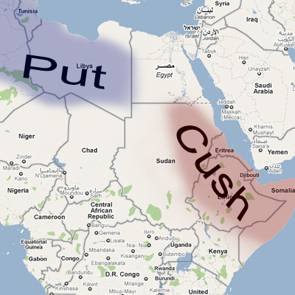

**<Note>**

Barack Obama, Sr. (From Wikipedia, the free encyclopedia)

Barack Hussein Obama, Sr. (1936−1982) was a Kenyan senior governmental economist, and the father of the 44th President of the United States, Barack Obama. He is a central subject in his son's memoir, Dreams from My Father.

**(True Vine)** The religion of the land of Midian (southern Jordan and Saudi Arabia) is Islam. The curtains are used for temples (or tents). Therefore, 'the curtains of the land of Midian' mean Islamic temples on the Temple Mount in Jerusalem managed by Arabs. Mosques on the Temple Mount managed by Arabs (the Dome of the Rock and the al-Aqsa Mosque) will tremble and might collapse by the 12 point strong earthquake.

[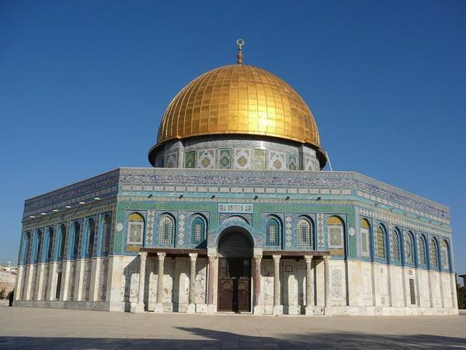](https://www.google.co.kr/url?sa=i&rct=j&q=&esrc=s&frm=1&source=images&cd=&cad=rja&uact=8&ved=0CAcQjRw&url=https://www.travelblog.org/Photos/759564&ei=dqONVeiROaaxmwWp6JXYAQ&bvm=bv.96783405,bs.1,d.dGY&psig=AFQjCNHP5ll3mPRKrCdt0dkCgQ3wW0TLcQ&ust=1435430569870743) [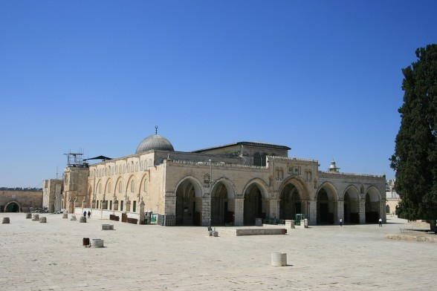](http://www.google.co.kr/url?sa=i&rct=j&q=&esrc=s&frm=1&source=images&cd=&cad=rja&uact=8&ved=0CAcQjRw&url=http://blog.daum.net/sunghwa/15853379&ei=KqONVavDLKOsmAW1l7fwDA&bvm=bv.96783405,d.dGY&psig=AFQjCNFLhdTQodr7x0dwMPDh_wQ_GGwVhg&ust=1435431743832351)

**\* The Dome of the Rock (It looks like the curtains cover the walls of the structure.) / the al-Aqsa Mosque**

**(Habakkuk 3:8)** Was the LORD displeased against the rivers? Was thine anger against the rivers? Was **thy wrath against the sea**, that thou didst ride upon thine horses and thy chariots of salvation?

**(True Vine)** **'Thy wrath against the sea...'** indicates the same timeline as in **Luke 21:25 '...the sea and the waves roaring'** when there shall be signs in the sun, and in the moon, and in the stars. In other words, 2014-2015 when heavenly signs have appeared is the time for tsunami/tidal waves!

**(Habakkuk 3:10)** The mountains saw thee, and they trembled: **the overflowing of the water** passed by: **the deep uttered his voice, and lifted up his hands on high**.

**(Prophet Efrain)** ... All rivers will overflow due to coastal flooding. Tsunami/Tidal wave. It may take from seconds to hours to arrive in your country. (Depending on the distance of your country from the place of impact).

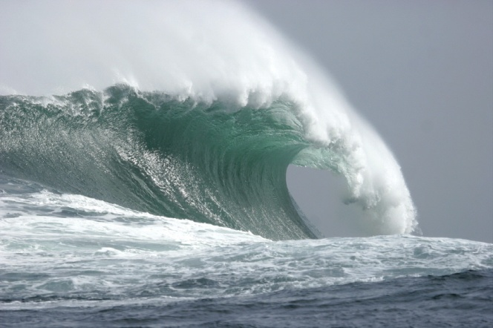 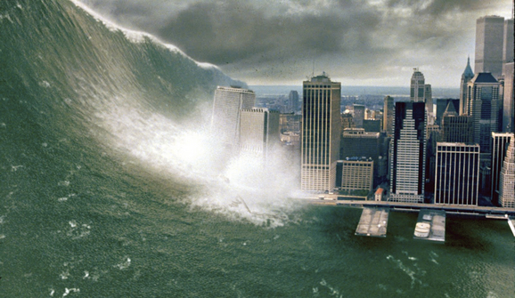

**(Habakkuk 3:11) The sun and moon stood still** in their habitation: at **the light of thine arrows** they went, and at **the shining of thy glittering spear**.

**(Prophet Efrain)** ... The rotation of the earth will stop due to the impact. It will be three days of darkness in places that are not under the light of the sun at that time.... The impact of the asteroid will be identical to a nuclear explosion.

**(True Vine)** 'the light of thine arrows' and thy glittering spear' means asteroids/meteors. 'Shining' means explosion.

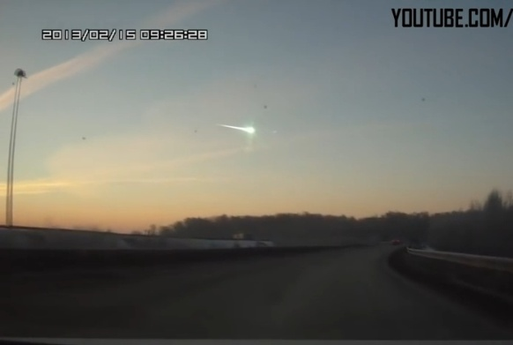 

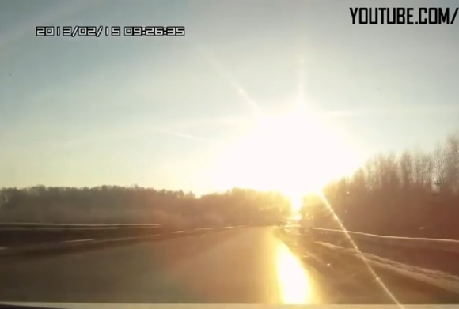 

**\* A meteor exploded over Chelyabinsk on February 15, 2013.**

**(Habakkuk 3:12)** Thou didst march through the land in indignation, thou didst thresh **the heathen** in anger.

**(Prophet Efrain)** ... The priority of this message is God's judgment for His pastors and apostate church across the island of Puerto Rico. It will start there and then spread to the Caribbean, the U.S., Central and South America, Canada and Europe.

**(Habakkuk 3:17)** Although the fig tree shall not blossom, neither shall fruit be in the vines; the labour of the olive shall fail, and the fields shall yield no meat; the flock shall be cut off from the fold, and there shall be no herd in the stalls:

**(Prophet Efrain)** ... Scarcity. Shortages of water, food, medications and resources for at least 15 months. Martial Law will be established throughout the whole world to deal with the shortages and unrest in the population.

**(True Vine)** I think drought and famine will continue even after 15 months. Our life will be different from now after the impact.**>>> IMMINENT ASTEROID IMPACT PROPHECY OF THE LORD (Summary) <<<**

**Prophet Efrain Rodriguez, 2014**

ALL COUNTRIES WILL BE AFFECTED BY THIS COMING EVENT, ESPECIALLY IF THEY ARE PART OF THE CARIBBEAN, LATIN AMERICA, CANADA AND UNITED STATES. THIS IS A PUNISHMENT AND CLEANSING FOR THE WHOLE WORLD, NOT ONLY FOR THOSE WHO LIVE NEAR THE SEA. EUROPEAN COUNTRIES WILL ALSO RECEIVE THE EFFECT OF THE SHOCK WAVE, THE TSUNAMI AND THE SUBSEQUENT EFFECTS.

THIS COMING EVENT IS NOT PART OF THE JUDGMENT EVENTS DESCRIBED IN THE BOOK OF REVELATION. WE ARE NOT IN THE GREAT TRIBULATION YET. THIS ASTEROID IS NOT WORMWOOD.

THIS EVENT WILL HAPPEN BEFORE THE RAPTURE OF THE CHURCH. IT IS A PUNISHMENT AND CLEANSING FOR THE APOSTATE CHURCH WHO LIVES IN THE WHOLE WORLD, TO PREPARE THE FAITHFUL REMNANT FOR THE RAPTURE OF THE TRUE CHURCH. THE PRESENT CHURCH IS NOT PREPARED TO GO IN THE RAPTURE.

THERE IS LITTLE TIME LEFT.

THE MESSAGE IS THE SAME FOR ALL: PREPARE YOUR SOULS WITH THE LORD JESUS CHRIST AS ARK OF SALVATION, AND STORE WATER, MEDICINES AND FOOD TO THE EXTENT YOU CAN. THE AUTHORITIES ARE PREPARING FOR AT LEAST 15 MONTHS OF SCARCITY. IF YOU HAVE DELIVERED YOUR SOUL AND TRUST IN CHRIST, HE WILL PROVIDE YOU WITH WHAT YOU NEED.

The impact of the asteroid will occur at 2:00 in the morning at sea, in the area west of Puerto Rico. Calculate the equivalent time in your country. The impact will stop the rotation of the Earth for three days. The time in your country at the time of the impact, in Puerto Rico, will be the time in which your country will remain for those 3 days, be it night or day.

The order of events is:

1. The fall of the asteroid

2. The rotation of the Earth will stop due to the impact. It will be three days of darkness in places that are not under the light of the Sun at that time.

3. A 12 point earthquake, nearly simultaneous. It is the Presence of the Lord on Earth. It will be felt around the whole world.

4. Shock wave will travel the world. It will come quickly because it moves at an incredible speed. It will bring winds of 300 miles per hour.

5. Tsunami/Tidal wave. It may take from seconds to hours to arrive in your country. (Depending on the distance of your country from the place of impact). All rivers will overflow due to coastal flooding.

6. Plague/Pestilence as a result of the bodies decomposed in the waters and land, not buried because of the 3 days of darkness, and due to the flooding of rivers and seas. It will be very difficult to get rid of the bodies.

7. Scarcity. Shortages of water, food, medications and resources for at least 15 months. Martial Law will be established throughout the whole world to deal with the shortages and unrest in the population.

All these events will claim many lives, in particular the plague.

**\* Official Website/Facebook**

**Prophet Efrain Rodriguez**

**http://www.profeta-de-dios-efrain.com/311084259**

**A Call and Warning from the Lord - Asteroid Prophecy**

**https://www.facebook.com/permalink.php?story\_fbid=1023697487643376&id=692795807400214**

**>>> Message from the Lord about the Rapture (True Vine, May 11, 2015) <<<**

The Holy Spirit once spoke to me about the rapture as below, which will not be a one-time event, but what I heard is that the rapture will take place 4 times.

**About the Rapture:**

[First] Philadelphia going up, **unknown** to the world **(a few)**

[Second] Remnants and World Church going almost at the same time appointed from the beginning right before the 7 Year Tribulation **(majority)**

[Third] Two witnesses including some saved **(a few)**

[Final] After the Great Tribulation. Remaining believers. A few will stay alive with amazing preparations in place. **(a few)**

The Holy Spirit told me that “No one is sure about what the hour of the rapture will be. It is written in the biblical passage. 2015 will be a starting of sorrows. Judgment is on the way to the US, Canada, Central and South America. Lunar eclipses warn Israel and the Church. Solar eclipses warn the fate of the entire world.”

(This may sound very very strange, but I sincerely ask everyone reading this article to pray for confirmation from the Lord. Actually, I also need confirmation for this message through other believers. Please pray. May God Bless You All.)